**CS 487 DATA SECURITY**

**HOP08 – Deploy Recovery Service Vault and Backup Policy**

1/28/2020 Developed by Mary Oh

Center for Information Assurance (CIAE) @City University of Seattle (CityU)

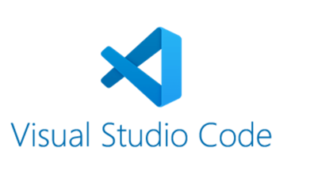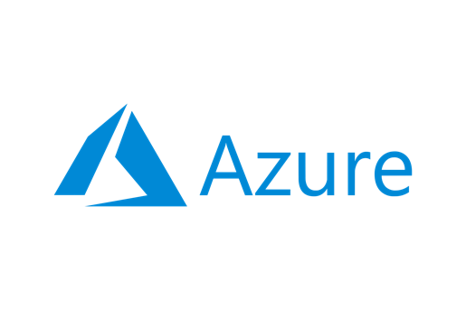

**Before You Start**

* Version numbers may not match with the most current version at the time of writing. If given the option to choose between stable release (long-term support) or most recent, please choose the stable release rather than beta-testing version.
* This tutorial targets Windows users and MacOS users.
* There might be subtle discrepancies along the steps. Please use your best judgement while going through this cookbook style tutorial to complete each step.
* For your working directory, use your course number. This tutorial may use a different course number as an example.
* The directory path shown in screenshots may be different from yours.
* If you are not sure what to do or confused with any steps:
  + Consult the resources listed below.
  + If you cannot solve the problem after a few tries, ask a TA for help.

**Learning Outcomes**

* Learn how to use Visual Studio Code to deploy Recovery Service Vault and Backup Policy

**Resources**

* Microsoft Azure - [https://azure.microsoft.com/](https://azure.microsoft.com/en-us/overview/what-is-azure/?&ef_id=Cj0KCQiAlsv_BRDtARIsAHMGVSac9cd8I7htfl0EVYTYDUBxYJ7mEqQ6dB5bRem2ziaBp-j1Di4wui8aAivlEALw_wcB:G:s&OCID=AID2100131_SEM_Cj0KCQiAlsv_BRDtARIsAHMGVSac9cd8I7htfl0EVYTYDUBxYJ7mEqQ6dB5bRem2ziaBp-j1Di4wui8aAivlEALw_wcB:G:s&gclid=Cj0KCQiAlsv_BRDtARIsAHMGVSac9cd8I7htfl0EVYTYDUBxYJ7mEqQ6dB5bRem2ziaBp-j1Di4wui8aAivlEALw_wcB)
* Microsoft Documentation - <https://docs.microsoft.com/>

**What is Azure?**

Azure cloud platform is cloud services designed to help bring new solutions to life. You can build, run, and manage application across multiple clouds, on-premises, and at the edge, with the tools and frameworks of your choice.

**What is Recovery Service Vault?**

Recovery Service Vault is a storage entity in Azure that houses data such as copies of data, or configuration information for virtual machines (VMs), workloads, servers, or workstations. This can also be used for various of Azure services such as IaaS VMs and Azure SQL Databases.

**What is Backup Policy?**

Backup Policy provides backup for virtual machines by using custom-defined backup policies in a Recovery Services Vault. Customers can manage backup policies and model them to meet their changing requirements from a single window. They can edit a policy, associate more virtual machines to a policy, and delete unnecessary policies to meet their compliance requirements.

**Using ARM template**

1. Download the attached json files.
2. Open the json files with Visual Studio Code.
3. Open the integrated Visual Studio Code terminal using ctrl + ` key.
4. Sign in using your Azure account information. This will open up a new window to sign in.

1. Create the resource group.

The ARM templates create both Recovery Service Vault and Daily Backup Policy.

1. Under parameters file, modify the value of the “vaultName” to <yourNameVault>. You may choose to modify the other parameters as needed. However, for our purpose, we can leave it as is since we are doing daily backup.

|  |  |
| --- | --- |
| **Parameter** | **Description** |
| vaultName | Name of the Recovery Services Vault |
| policyName | Name of the Backup Policy |
| scheduleRunTimes | Times in day when backup should be triggered. e.g. 01:00 or 13:00. Must be an array, however for IaaS VMs only one value is valid. This will be used in LTR too for daily, weekly, monthly and yearly backup. |
| timeZone | Any Valid timezone, for example:UTC, Pacific Standard Time. Refer: https://msdn.microsoft.com/en-us/library/gg154758.aspx |
| instantRpRetentionRangeInDays | Number of days Instant Recovery Point should be retained |
| dailyRetentionDurationCount | Number of days you want to retain the backup |
| daysOfTheWeek | Backup will run on array of Days like, Monday, Tuesday etc. Applies in Weekly retention only. |
| weeklyRetentionDurationCount | Number of weeks you want to retain the backup |
| monthlyRetentionDurationCount | Number of months you want to retain the backup |
| monthsOfYear | Array of Months for Yearly Retention |
| yearlyRetentionDurationCount | Number of years you want to retain the backup |

1. Make sure to save all your changes.

**Deploy template to Azure**

1. Deploy the template. Type the following command. Ensure you are in the correct directory where the file is saved.

1. Verify that your deployment was successful. Open your browser and head to your Azure portal. Select Resource Groups.
2. Locate and open the resource group. Verify that the recovery service vault is successfully deployed.

1. Select your recovery service vault. Locate Backup Policies under manage on the menu options. You should be able to see your DailyBackupPolicy1 that we deployed.

1. To avoid incurring any unnecessary fees, clean up resources. Delete your Recovery Service Vault.

1. Delete your resource group using your command line.



1. Verify cleaning up of resources is successful. Head to your Azure in your web browser and refresh. The resource group should not be showing.

**Questions you can answer for submissions:**

1. **Knowledge:** Why is Backup Policy important?
2. **Knowledge:** What is Backup Policy? Provide an analogy to understand it better.
3. **Knowledge:** What are the benefits of having backup policy?
4. **Knowledge:** What are the different types of backup policies that we can deploy?
5. **Application:** When to use Backup Policy? Why?
6. **Application:** Best use of each type of Backup Policy? Why?

**Push your work to GitHub**

1. Open the integrated Visual Studio Code terminal using ctrl + ` key. Make sure you are in the right path.
2. Type the following command:

git add . (to copy all changes you have made)

git commit -m “Submission for Module 8 - YourGitHubUsername” (To add a message to your submission)

git push origin master (to upload your work to Github)